Sustainable Bond Framework
  - May 2026

Acknowledgment of Country
Treasury Corporation of Victoria acknowledges that Aboriginal and Torres Strait Islander peoples are the First Peoples and Traditional Custodians of Australia, and the oldest continuing culture in human history.
We proudly acknowledge Victoria’s Aboriginal communities and recognise the value and ongoing contribution of Aboriginal people and communities to Victorian life. We pay our respect to Elders past, present and emerging.

Contents
Introduction 5
SECTION 1 – Victoria’s sustainability ambition 7
1. Charting Victoria’s climate leadership 7
Victoria’s Climate Change Strategy 8
Embedding climate action in Victorian Government decision-making 8
1.1. Net zero economy 8
1.2. Climate resilience 11
2. Victoria at the forefront of environmental progress 12
2.1. Safe, sustainable and productive water sources 13
2.2. Improving Victoria’s environment 14
Protecting Victoria’s natural environment and biodiversity 14
Investing in early intervention for improved life outcomes 15
3.1. Inclusive and equitable community 16
SECTION 2 – Treasury Corporation of Victoria and sustainability 19
4. About TCV 19
4.1. Sustainability at TCV 19
5. TCV Sustainable Bond Framework 21
5.1. Use of proceeds 22
5.2. Process for project evaluation and selection 32
5.3. Management of proceeds 37
5.4. Reporting 38
5.5. External review 39
5.6. Continuous Improvement 39
6. Appendix 39
7. Disclaimer 44

Introduction
Victoria is entering a decisive decade for climate action, environmental stewardship and social progress.
The State has set ambitious, legislated pathways to reduce emissions, strengthen climate resilience and improve the wellbeing of vulnerable communities. These policy commitments are supported by significant public investment in renewable energy, clean transportation, sustainable water and land management, social and affordable housing, inclusive and leading education and vocational programs. Delivering on these priorities requires coordinated action across Government, alongside the transparency that allow investors to understand – and participate in – Victoria’s sustainability agenda.
As the State’s central financing authority, Treasury Corporation of Victoria (TCV) plays a central role in partnering with the Victorian public sector to fund essential assets and services, and in doing so, supports the State’s climate, environmental and social objectives. In this way, TCV’s Sustainable Bond program enables the delivery of measurable, long term benefits for the community.
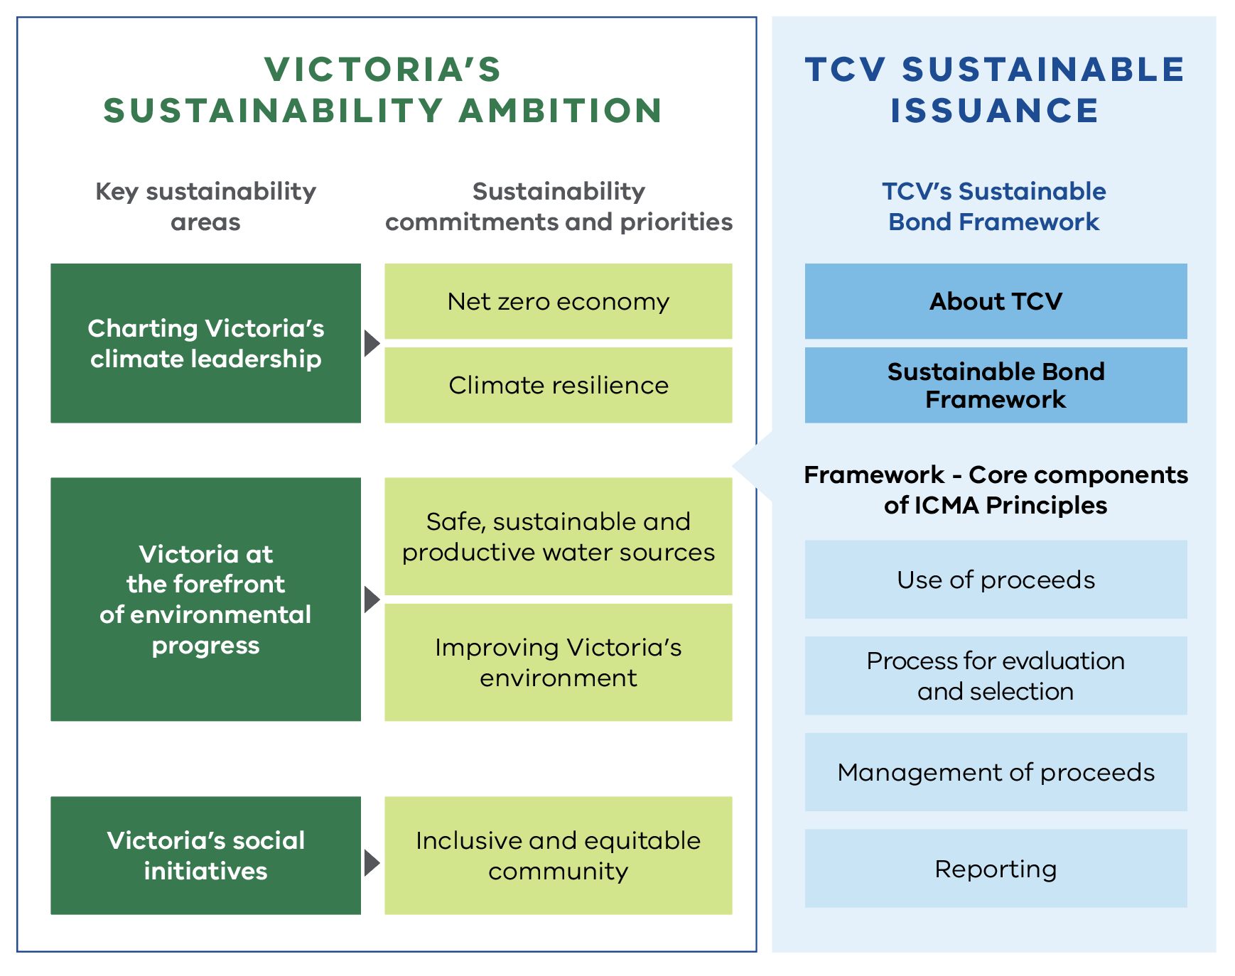
Figure 1. Overview of Victoria’s sustainability ambition and sustainable issuance
This Sustainable Bond Framework sets out the governance, processes and criteria that guide TCV’s sustainable issuance. It articulates the Eligible Expenditures that may be financed or refinanced through Sustainability Instruments, the eligibility criteria applied, and the approach to evaluating, selecting and managing eligible projects. The Framework reinforces TCV’s commitment to credibility and transparency, with clear requirements for allocation and impact reporting, external verification, and ongoing alignment with evolving standards, including the International Capital Market Association (ICMA) Principles and the Australian Sustainable Finance Taxonomy.
Through this Framework, TCV aims to provide investors with a comprehensive and credible view of how sustainable finance supports Victoria’s transition to a net zero and climate-resilient economy, protects and restores natural ecosystems, and advances social equity across communities. It reflects the Victorian Government’s long-term policy direction, and, by enabling capital to be raised for initiatives that deliver meaningful environmental and social impact, is a core part of TCV’s contribution to a better future for Victoria.

SECTION 1 – Victoria’s sustainability ambition
The Victorian Government’s key climate, environmental and social policies
2017: Climate Change | First Australian jurisdiction in the world to legislate net-zero emissions and renewable energy targets.
2017: Biodiversity 2037 | Plan for stopping the decline of native plants and animals and improve Victoria’s natural environment.
2020: Big Housing Build | Investment in social and affordable housing for Victorians in need.
2020: Recycling Victoria: A new economy | Initiative to cut waste, boost recycling and reuse of precious resources.
2022: Adaptation Action Plans | Action plans across seven systems to ensure Victoria’s climate resilience now and into the future.
2024: Best Start, Best Life | Reforms and investment into early childhood education.
2025: Victoria’s Statewide Treaty | A Treaty to recognise First Peoples and shared decision‑making toward a fairer future.

1. Charting Victoria’s climate leadership
The Victorian Government is committed to reducing Victoria’s emissions to net zero by 2045.
It is working to ensure communities, businesses and institutions are better prepared to deal with the impacts of climate change. These actions are underpinned by the comprehensive Climate Action Act 2017 (Vic).
Climate change is already affecting Victoria, and the impacts are projected to intensify in the coming decades. The State has warmed by 1.4°C since pre-industrial times, with more frequent heatwaves, very hot days, and declining cool-season rainfall. Climate projections show continued warming, increased extreme weather and sea-level rise under all emissions scenarios. These changes will disrupt ecosystems, supply chains, the availability of goods and services, agricultural productivity, security and human wellbeing.
Climate related impacts are particularly significant for Traditional Owners, affecting their rights and obligations to care for Country and threatening tangible and intangible cultural and biocultural values.
The impacts of climate change require strategic decision making and actions to mitigate and adapt to the effects.

Victoria’s Climate Change Strategy
Victoria’s Climate Change Strategy sets the course for Victoria reducing emissions and strengthening climate resilience over 2026‑30. The Strategy outlines the breadth and depth of climate action in Victoria, from the transition to renewable energy, and providing Victorians with greater sustainable transport options, to supporting Victorian farmers to lower their emissions, sustainable land use and forestry conservation.

Embedding climate action in Victorian Government decision-making
The Victorian Government’s Climate-related Risk Disclosure Statement builds transparency and supports investors, lenders, credit rating agencies and the public to understand the Government’s approach to identifying and managing climate-related risks and opportunities. This second statement demonstrates improvements in the Government’s understanding of the economic and fiscal impacts of climate change, and entity-level climate risk management.

1.1. Net zero economy
Sustainability objective: Climate change mitigation
To reduce Victoria’s greenhouse gas emissions consistent with its legislated long-term emissions reduction target of net zero by 2045 and interim emissions reduction targets.

Emissions reduction targets
Victoria was one of the first jurisdictions in the world to legislate net zero emissions targets through the Climate Action Act 2017 (Vic). The Act legislates a long-term target for net zero greenhouse gas emissions by 2045, with interim targets to reduce emissions below 2005.
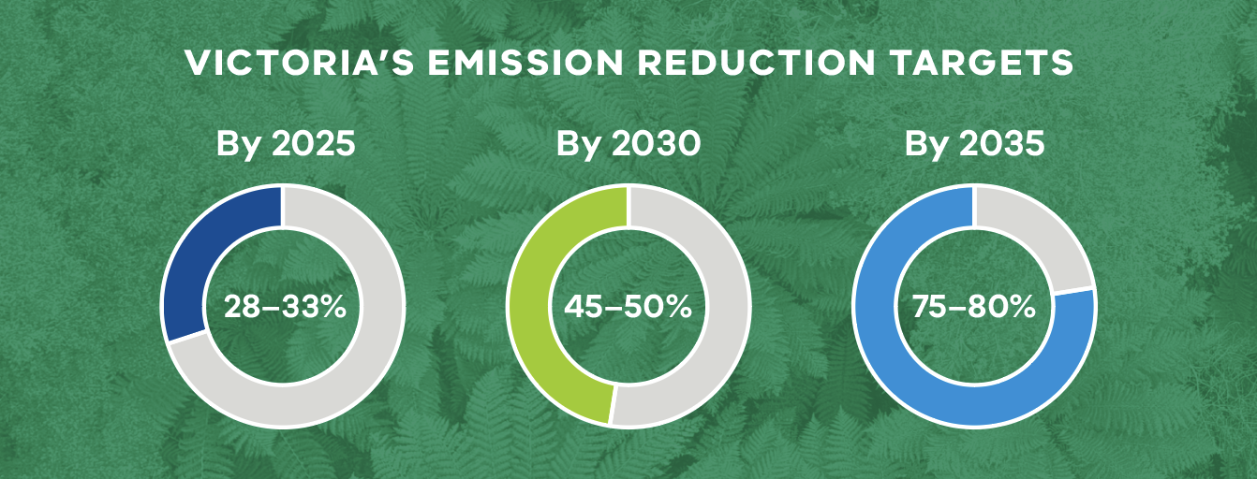
Alongside Victoria’s Climate Change Strategy, the Government publishes sector emissions reduction pledges every five years. The pledges detail actions key sectors of the economy are taking to progress towards these targets.
The Victorian Government is also supporting investment and delivery of public assets aligned with its legislated target by considering climate change and emissions reduction in decision making and budget processes.

Decarbonising our energy supply
Victoria’s commitment to renewable energy is underpinned by the Renewable Energy (Jobs and Investment) Act 2017 (Vic), which legislates the State’s targets for renewable generation and storage. The legislated targets include:
- Victorian renewable energy target (VRET) of 65% by 2030 and 95% by 2035
- energy storage targets of at least 2.6 gigawatts (GW) of energy storage capacity by 2030 and at least 6.3 GW by 2035
- offshore wind targets of at least 2 GW of offshore wind generation capacity by 2032, 4 GW by 2035 and 9 GW by 2040.
This legislative framework provides long-term policy certainty and boosts investor confidence, enabling the development of renewable energy projects that will deliver reliable, affordable and clean electricity for Victorians.

Plans to guide the energy transition
Over the past decade, the Victorian Government has been a leader in complex energy policy reform. Its comprehensive plan – Cheaper, Cleaner, Renewable: Our Plan for Victoria’s Electricity Future (2024) – outlines the actions to ensure the State achieves its renewable energy targets, including investment opportunities for the private sector to partner with Government through to 2035.
Key achievements to date have included facilitating the State’s transition away from a dependence on fossil fuels and exceeding the State’s 2025 target of 40% renewable electricity generation.
The Victorian Government has established in legislation, and enshrined in the Victorian Constitution, the State Electricity Commission (SEC) – a government-owned renewable energy company. The SEC aims to invest in renewable energy and storage projects that accelerate the transition and deliver sustainable returns; supporting households to go all-electric to reduce energy bills and emissions and build the renewable energy workforce the energy transition requires.
The Government’s 10-year Solar Homes Program further aims to contribute to statewide progress towards VRET, through the expansion of household renewable generation (rooftop solar) and storage.
Victoria is actively planning for and enabling the new electricity transmission grid that our new renewable energy generation will require. VicGrid is a Victorian Government agency working closely with the private sector to deliver the strategic, long-term plan for renewable energy zones and transmission infrastructure. This includes planning, development and investments into transmission projects, while actively engaging with the community.
The Victorian Government’s Gas Substitution Roadmap and updates lay out a pragmatic and comprehensive response to the State’s gas transition needs. It combines a reduction in household demand for gas with new supply and storage, including for the businesses and industries that require gas.

Reducing emissions from our energy use
Regulations and targeted programs are delivering major increases in the electrification of households and buildings, reduced gas use and improved energy efficiency.
The Victorian Energy Efficiency Target Act 2007 (Vic) (VEET Act) sets out a legislative framework to promote the reduction of greenhouse gas emissions and encourage the efficient use of electricity and gas. The Victorian Energy Upgrades program was established by the VEET Act, commenced on 1 January 2009, and is legislated through to 2045. Underpinned by a legal obligation on energy retailers, the program provides financial assistance to households and businesses adopting more energy efficient appliances or practices, including hot water systems, heating and cooling, and large-scale, bespoke upgrades for commercial and industrial businesses.
Victorian regulations – those already in place and others that will take effect in 2027 – will increasingly drive the uptake of electric appliances in new and existing homes. Buildings with better energy performance have significant social benefits and support an inclusive, equitable and healthy community.

1.2. Climate resilience
Sustainability objective: Climate change adaptation and resilience
To ensure a coordinated response to climate change impacts with the aim to build resilience, reduce risks and prepare communities, infrastructure and ecosystems for a changing climate.
The Victorian Government has prepared
Adaptation Action Plans (AAPs) across seven systems specified in the Climate Action Act 2017 (Vic). The systems for which AAPs have been developed include the Built Environment, Education and Training, Health and Human Services, Natural Environment, Primary Production, Transport and the Water Cycle.
These systems are either vulnerable to climate change impacts or critical to ensure Victoria’s current and future climate resilience. Each AAP is tailored to each of the seven systems’ own unique climate change risks and opportunities. Collectively, the AAPs build climate resilience of public assets and services, adapt government policies and operations, and support partnerships with Traditional Owners, industries, workers and communities to build Victoria’s resilience to our future climate.
Each plan sets out:
- the challenges of climate change for each system
- the extensive work already underway
- the key priorities over the next five years.
Flood and bushfire risk management are central to Victoria’s climate resilience strategy and form a core component of the State’s approach to managing material physical climate risks.

Flood risk investment
In response to the Parliamentary Inquiry into the 2022 flood event, the Victorian Government is making state policy and accountability changes to facilitate faster risk-based planning and land use development decisions. This will improve the way flood risk information is updated and shared to support a hazard-based approach and complement state-led planning scheme amendment processes.
The Victorian Government is supporting accelerated delivery of flood studies for emergency management activities, Victorian planning schemes and decisions, to better prepare communities, and mitigate against future floods.

Bushfire risk investment
The Victorian Government uses a broad range of interventions and activities to manage bushfire risk. These include modelling and risk‑based framework that includes:
- land-use planning, building and infrastructure standards
- Capacity building and engagements with Traditional Owners and industry
- planned burning and fuel management programs
- compliance and enforcement.

2. Victoria at the forefront of environmental progress
The Victorian economy depends on natural resources. However, the value of our natural resources is not only from their use as direct inputs to production, but also for their benefits to society, such as living trees that sequester carbon and help clean the air.
Victoria’s environmental objectives are to conserve natural resources and to protect and maintain ecosystems to support the wellbeing of current and future generations. These objectives are being pursued via strategies and actions to:
- improve the environmental condition of Victoria’s waterways and catchments
- protect and build a resilient and biodiverse environment
- reduce the harmful effects of pollution and waste
- partner with Traditional Owners to care for land, waterways, coasts and parks.

2.1. Safe, sustainable and productive water sources
Sustainability objective: Sustainable management of water resources
To increase the security of supply and efficient use of water and improve wastewater treatment and the environmental condition of waterways, to ensure Victoria has safe and sustainable water resources to meet future urban, rural and environmental needs.
The water cycle system involves the collection, storage, treatment, delivery and supply of water, as well as services for managing wastewater, drainage and flooding. The impacts of climate change are already being felt across the water cycle system and are likely to increase. Addressing the impacts of climate change is important due to Victoria’s reliance on climate-dependent sources of water found in reservoirs, rivers, lakes and groundwater. Climate change sits alongside other pressures on water resources, such as Victoria’s population growth and changing economic conditions.
To achieve the objective of sustainably managing water resources, the Government is delivering a range of strategies and actions targeted at:
- assessing risks to water availability and quality, including from climate change, to ensure informed decision making
- increasing the diversity, security and resilience of Victoria’s water systems
- improving the efficiency of water use
- improving the environmental condition of Victoria’s waterways and catchments
- improving the water sharing framework to adapt to emerging uses and values
- incorporating more social and community values in water management
- reducing greenhouse gas emissions from water sector activities – contributing to Victoria’s net zero emissions target by 2045
- adopting new water, wastewater and waste treatment technology, use of recycled materials and circular economy solutions
- partnering with Traditional Owners to embed their knowledge systems in water management and to support the delivery of their self-determined water priorities
- improving water sector governance, systems integration and water emergency management.

2.2. Improving Victoria’s environment
Sustainability objective: Healthy, resilient and biodiverse environment
To value nature and develop policies and actions to protect Victoria’s natural environment and reduce biodiversity decline, deliver ecosystem resilience and build a circular economy.

Protecting Victoria’s natural environment and biodiversity
Across Victoria, biodiversity is in decline and reversing this trend will require significant, coordinated effort. To minimise poor economic, social and environmental outcomes associated with biodiversity loss, it is essential to foster shared responsibility and drive collaboration and investment from across government, private sector and philanthropy.
Protecting Victoria’s Environment – Biodiversity 2037 is the Victorian Government’s 20-year strategy to halt the decline of biodiversity and improve the health of the State’s natural environment. Launched in 2017, it represents a shift toward a more integrated, science-based and community-driven approach to conservation.
This includes biodiversity response planning with communities and Traditional Owners, supporting self-determination and cultural knowledge.
Implementing the strategy will require a Whole of Government approach, delivering a range of policies and programs targeted at:
- integrating biodiversity considerations into urban planning and infrastructure
- supporting agricultural primary producers through sustainable agribusiness initiatives
- advancing sustainable forest management and promoting economic development, industry diversification and job creation in communities affected by the end of commercial native timber harvesting from state forests
- supporting the establishment of trees in rural landscapes for timber production, natural capital values and carbon sequestration
- enhancing sustainable management of public land and parks
- improving native species populations and their habitats across Victoria
- regulating public land use and implementing Victoria’s Bushfire Management Strategy
- supporting Traditional Owners to care for Country.

Pollution prevention and building a circular economy
Recycling Victoria: a new economy is the Victorian Government’s 10-year circular economy policy and action plan. The policy aims to reduce waste, increase recycling, create jobs and build a circular economy that makes more productive use of our resources.
It is delivering a range of economy-wide benefits to Victorians through:
- increased recycling rates and resource recovery – reducing landfill and capturing greater value from materials
- increased productivity from more effective use of materials and creation of new products and services that turn waste into resources
- more jobs in recycling and manufacturing
- empowered communities through education, grants and local initiatives
- cost savings for households through extended product life and reduction in waste
- reduced greenhouse gas emissions from landfills – contributing to Victoria’s net-zero emissions target by 2045
- reduced litter and pollution from waste in the environment.
Pollution prevention and building a circular economy is a strategic priority for Victoria and the mechanism by which these initiatives are being funded is via the Sustainability Fund.
The Victorian Government addresses social impact and risks through its broader social policy agenda.
This agenda is a comprehensive, multi-sector strategy aimed at building a fairer, healthier and more inclusive society. It is coordinated across government departments and agencies, with a strong emphasis on equity, wellbeing, community empowerment and delivery of reforms in housing, mental health, education and employment.

Investing in early intervention for improved life outcomes
The Early Intervention Investment Framework (EIIF) is a strategic funding mechanism used by the Victorian Government to improve life outcomes for a diverse cohort of individuals and reduce pressure on acute services by funding timely and targeted early interventions. It aims to shift resources toward early support rather than reactive, crisis-driven services.
The EIIF supports diverse groups, for example:
- people experiencing homelessness
- families with children at risk of entering care
- disengaged youth with acute mental illness or chronic health conditions.
The EIIF is now embedded in Victoria’s annual budget process, ensuring sustained focus and accountability.

3.1. Inclusive and equitable community
Sustainability objective: Socioeconomic advancement
To support vulnerable Victorians and the community through investments in social and affordable housing, develop leading education and vocational training programs and other initiatives that promote inclusive and equitable outcomes.

Social and affordable housing
The Victorian Government has embarked on delivering equitable access to affordable housing that is inclusive, safe and secure for Victorians in need, while also aiming to:
- reduce homelessness
- support economic recovery
- create jobs and boost local economies
- build inclusive, well-designed communities.
Over the last decade, Victoria has undertaken the largest-ever investment in social and affordable housing to ensure more Victorians have the security and stability of a home.
The landmark investments include:
- Big Housing Build
- Includes social, affordable and market rental homes.
- Built to modern, accessible and energy efficient standards.
- High-rise redevelopment
- Commitment to replacing 44 ageing public housing towers in Melbourne with modern, accessible and energy efficient homes.
- Will deliver at least 10% more social housing.
- Includes new community facilities and green spaces.
- Regional Housing Fund
- Dedicated to regional and rural Victoria, this is delivering new and upgraded homes.
- Ground Lease Model
- Public land leased to consortia to build, operate and maintain housing for 40 years.
- Delivers a mix of social, affordable, specialist disability and market rental homes to grow social housing and address housing affordability.
- Social Housing Growth Fund
- Financial support for community housing providers to expand social housing supply.
- Affordable Housing Investment Partnership
- A concessional loan and guarantee program that partners with community housing providers to deliver sustainable social and affordable housing, leveraging government investment to attract private capital and increase housing supply at scale.

Investing in Victoria’s inclusive and leading education system
The Victorian Government’s strategic vision for driving and reform across the education system is ‘A great education for every child and young person – so they can thrive now, and in the future, for a fairer, smarter and more prosperous state’.
The key strategic objectives include:
- Early Childhood Outcomes – improve development outcomes for 3- and 4-year‑olds before school and deliver a step-change for access and equity in early childhood education
- School Outcomes – raise standards in learning and student engagement, wellbeing and development
- Equity and Inclusion – ensure education is equitable and inclusive for all children and young people, including closing the achievement gaps for students from disadvantaged backgrounds. Expand support for students with disability and diverse learning needs
- Pathways and Opportunities – senior secondary pathway reforms aim to improve transition from education to training/work and expand vocational and applied learning opportunities
- Child Safety – ensure children are safe from harm throughout their education journey.
The key initiatives that will support delivering the strategic objective include:
- investing in early childhood education, rolling out pre-prep in priority areas including the Government’s Best Start, Best Life reforms
- delivering the Disability Inclusion reform across all government schools
- expanding mental health practitioners in schools
- implementing the Middle Years Literacy and Numeracy Support initiatives
- enhancing digital learning infrastructure and cyber safety.

Training for the skills our economy needs
The Victorian Government continues to help Victorians gain the skills needed for employment, further education and to meet the changing needs of industry and business. Initiatives include:
- Free Technical and Further Education (TAFE) for learners in key industries and sectors
- strengthening the apprenticeship system and supporting access to job opportunities
- delivering a Housing Construction Centre of Excellence to train workers in modern construction technologies
- developing workers for an equitable and thriving renewable energy sector.

Victoria’s Statewide Treaty
Victoria has become the first jurisdiction in Australia to legislate Treaty with First Peoples. Treaty is about making a better and fairer state for all Victorians, by ensuring First Peoples have a say over the policies that impact them and their families.

SECTION 2 – Treasury Corporation of Victoria and sustainability

4. About TCV
Established by the Treasury Corporation of Victoria Act 1992 (Vic), TCV serves as the central financial institution for the State of Victoria.
TCV’s purpose is a better future for Victoria and the organisation supports the State, its clients and the broader community by sourcing capital and managing financial risk across the Victorian public sector.
TCV’s founding legislation mandates its role in acting for the benefit of the State and its clients. Services are provided to all government departments via the Department of Treasury and Finance (DTF), as well as to local councils and water corporations. TCV also supports agencies and organisations across sectors including housing, arts, sports, education, commercial and industrial real estate, healthcare, infrastructure, technology and transport.
In practice, TCV contributes funding and investment support for essential infrastructure – such as housing, schools, hospitals, roads, public transport and water systems – helping to build a more inclusive, connected and resilient Victoria. TCV also provides financing to advance the State’s climate action, energy transition and sustainability objectives.
By consolidating these functions, TCV achieves economies of scale, maintains a robust governance and risk management framework, employs highly skilled specialists, and delivers outcomes more effectively and competitively than if these functions were managed independently by the State or its clients.
This work strengthens the foundations of Victoria’s economy and public services, stimulates economic growth, and delivers long-term value and improved outcomes for communities across the State.

4.1. Sustainability at TCV

Carbon neutral operations
TCV is committed to improving our environmental awareness and the sustainability of our operations and business model. This has included progressing environmental projects as part of our core business activities, including attaining Carbon Neutral status as an organisation under the Australian Government’s Climate Active program. We continue to pursue areas of environmental performance where TCV can further reduce its operational footprint.

Social inclusiveness programs
As part of our commitment to diversity, equity and inclusion, TCV has implemented a Gender Equality Action Plan and a range of initiatives including:
- inclusive and accessible recruitment practices to ensure equal opportunity for all
- achieved balanced gender representation at organisational and leadership levels
- psychosocial and anti-bullying, harassment and discrimination policies and training
- hybrid, flexible work environment with varied leave entitlements and health and wellbeing programs.

Sustainable finance ambition
TCV’s Sustainability Strategy adopts an integrated approach to sustainable finance and identifies the need for coordination and collaboration between TCV and Government Departments and Participating Authorities. This allows TCV to respond effectively to the evolution of sustainable finance markets and meet investor expectations by providing a holistic view of government commitments and actions on climate, environmental and social issues, and the funding required to support these programs.
The aim of the strategy is to align TCV’s sustainability ambition to that of the broader Victorian Government and to position TCV as a leader in sustainable finance. This creates an avenue for TCV to proactively contribute to sustainable finance markets and Whole of Government sustainability agendas, while supporting its overall strategic goal to diversify funding and deliver better outcomes for the State and its clients. The objectives and priorities outlined in the Sustainability Strategy informs TCV’s future activities and initiatives.
TCV operates a sustainable bond program to fund Eligible Expenditures that support investment in Victoria and advance the State’s sustainability priorities. Key milestones achieved by TCV across its sustainability agenda are in Figure 2.
July 2016 | TCV became the first government sector issuer of Green Bonds in Australia and the Asia Pacific with its A$300m five-year issuance, certified under the Climate Bonds Initiative, funding energy efficient buildings, water infrastructure and electrified transport
January 2018 | TCV begins transacting Large Scale Renewable Energy Certificates and providing associated advisory services to assist Government clients with their renewable energy transition
September 2021 | TCV launched its Sustainability Bond program with EY pre‑assurance, issuing a A$2.5 billion benchmark bond in September 2021 to fund clean energy, housing and transport projects across Victoria
January 2023 | Issuance under the Framework reached A$5 billion
September 2024 | Issuance under the Framework reached A$10 billion
October 2024 | TCV recruited a Head of Sustainability to develop the Sustainability Strategy and accelerate the delivery of sustainability initiatives
February 2025 | TCV completed its Sustainability Strategy, identifying priorities to support Whole of Government sustainability, enable credible sustainable issuance and foster market development
2026 | TCV updated its Sustainable Bond Framework, aligning to ICMA Principles, market practices and investor preferences, and referencing the Australian Sustainable Finance Taxonomy to enhance credibility and transparency
Figure 2. The evolution of TCV’s sustainable bond program and priorities

5. TCV Sustainable Bond Framework
The TCV Sustainable Bond Framework (Framework) sets out the governance and processes by which TCV intends to issue and manage ‘Sustainability Instruments’.
These instruments are employed to finance, and refinance projects and assets, in whole or in part, and which are consistent with delivering on the Victorian Government’s sustainability priorities to achieve a net zero, climate resilient economy and positive environmental and social outcomes for Victoria.
The Sustainability Instruments issued under the Framework may include:
- TCV Green Bonds in accordance with the ICMA Green Bond Principles 2025
- TCV Social Bonds in accordance with the ICMA Social Bond Principles 2025
- TCV Sustainability Bonds in accordance with the ICMA Sustainability Bond Guidelines 2021
- other sustainable issuance as aligned to ICMA guidance, or industry standards and practices.
In accordance with the above ICMA Principles and best practice, the Framework covers four key components as follows:
- use of proceeds
- process for project evaluation and selection
- management of proceeds
- reporting.

5.1. Use of proceeds

Eligible Expenditure guidelines
An amount equivalent to the net proceeds from the issuance of Sustainability Instruments will be notionally allocated in whole or in part to finance or refinance existing or planned Eligible Expenditures:
- Green Bond proceeds will be allocated against Eligible Green Expenditures
- Social Bond proceeds will be allocated against Eligible Social Expenditures
- Sustainability Bond proceeds will be allocated against Eligible Green or Eligible Social Expenditures.
‘Eligibility criteria’ as referenced in this Framework are the requirements used by TCV to determine whether expenditures qualify as Eligible Green or Eligible Social Expenditures for sustainable issuance. A component is the technical screening criteria and/or industry standards. Eligibility criteria ensure that use of proceeds is aligned with Victorian Government sustainability priorities, ICMA Principles and are applied through a robust governance, evaluation and allocation process.
Each Eligible Green Expenditure category and Eligible Social Expenditure category has been mapped to the United Nations Sustainable Development Goals (UN SDGs) that they relate to. The UN SDGs are not themselves the eligibility criteria.

Financing and refinancing
Financed Eligible Expenditures are defined as those that occur in the current budget year or future budget years following the Sustainability Instrument issuance.
Refinanced Eligible Expenditures are defined as those that occur in the budget year prior to the Sustainability Instrument issuance. TCV will inform investors of the breakdown between financing and refinancing prior to the launch of new Sustainability Instruments.

Co-financing
Where Eligible Expenditures are co-financed, either with the private sector or the Commonwealth Government, only expenditure relating to the Victorian Government’s share of funding will be included in the Eligible Green or Social Expenditure pools.
Where data is available, impact reporting against co-financed projects will identify the proportion of funding contributed by the Victorian Government. Where data is not available, impact metrics will be identified and disclosed as being reported on a whole-of-project, asset or initiative basis.

Eligibility window
The net proceeds will be allocated to Eligible Expenditures incurred in the financial year preceding the issuance, the financial year of issuance and the two financial years following the issuance.
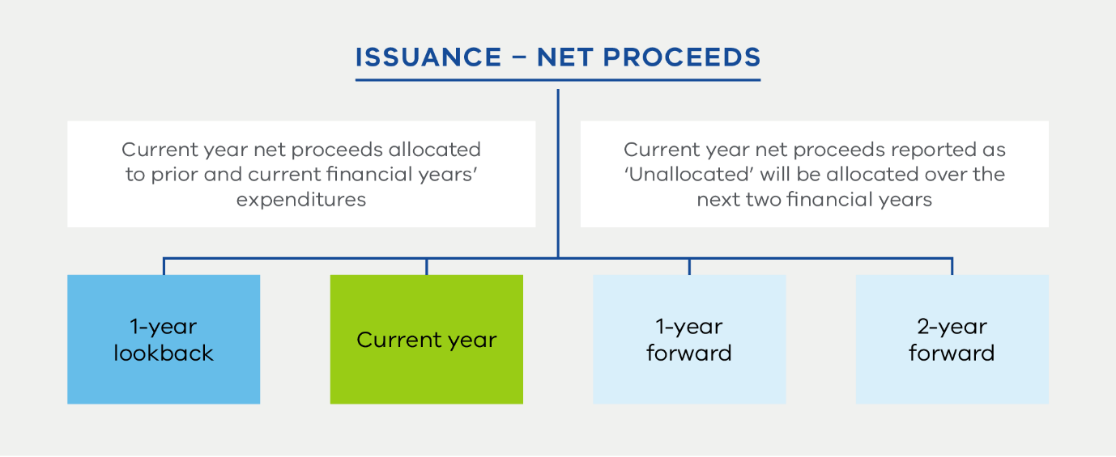
Figure 3. Eligibility window
As shown in Figure 3 above, TCV will allocate the net proceeds to refinancing (1-year lookback), and financing (current financial year’s expenditures). To the extent that there remains any unallocated net proceeds from the issuance, this will be held to be allocated over the next two financial years as the expenditures are incurred.

Excluded expenditures
To ensure alignment with the Victorian Government’s sustainability priorities, expenditures which knowingly cause, or are likely to cause, significant negative impacts in respect of wider environmental or social issues will not be considered eligible. Expenditures in the following sectors are specifically excluded from consideration as Eligible Expenditures:
- nuclear energy
- arms and ammunition manufacturing and chemical weapons
- manufacture, production or sale of alcohol, tobacco and other prohibited recreational drugs
- gambling
- development, refining and transportation of fossil fuels.

Technical screening criteria
Eligible Green Expenditure and Eligible Social Expenditure categories have been defined with reference to the ICMA Green Bond Principles and ICMA Social Bond Principles respectively.
Where applicable, technical screening criteria for Eligible Green Expenditures have been informed by the Australian Sustainable Finance Taxonomy (Taxonomy) recognising the Taxonomy’s high degree of relevance to the Australian market and TCV as an Australian issuer. Where no applicable technical screening criteria is available under the Taxonomy, TCV has endeavoured to define the technical screening criteria in alignment with other best practice criteria, such as the Climate Bonds Standard and other relevant guidance.

Eligible Green Expenditures
Eligible Green Expenditures are those which are consistent with delivering the Victorian Government’s sustainability priorities and may directly contribute to:
- climate change mitigation
- climate change adaptation and resilience
- sustainable management of water resources
- healthy, resilient and biodiverse environments.
TCV recognises the complexities of value chains in decarbonising energy supply and the role climate transition finance and green enabling projects can play to catalyse and support Victoria’s transition to a net zero economy. Where climate transition and green enabling projects are necessary components for eligible green projects to be developed, implemented or scaled, TCV will evaluate eligibility for inclusion in the Eligible Green Expenditures pool with reference to applicable guidance.
Table 1 details Victoria’s sustainability priorities and example Eligible Green Expenditures under the relevant ICMA category.
Table 1. Example Eligible Green Expenditures
Victorian sustainability priority | ICMA category | Example Eligible Green Expenditures | UN SDG alignment
Net zero economy | Renewable energy | - Solar energy facilities, including large-scale and rooftop solar photovoltaic systems and key components for solar energy generation, such as solar panels, inverters and solar hot water systems.  - Wind energy facilities, including onshore and offshore wind generation facilities, and key components for onshore or offshore wind energy generation such as, wind turbines and platforms.  - Electricity storage facilities, including battery storage.  - Facilities that produce renewable hydrogen, for example, via electrolysis, with renewable electricity or hydrogen derivative products such as green ammonia, green methanol or sustainable aviation fuel produced through the power-to-liquid process.  Supply chain infrastructure such as hydrogen storage, transport and conversion facilities.  Assets to enable the uptake of renewable hydrogen or hydrogen derivative products such as fuels cells, industrial equipment and infrastructure.  - Bioenergy facilities producing biofuel or biomass supply chain infrastructure or assets that enable the distribution or use of biofuel or biomass.  - Hydropower facilities, including run-of-river and impoundment and pumped storage.  - Electricity transmission and distribution infrastructure that increases integration of renewable electricity into the system. | 7, 8, 9, 13
Net zero economy | Green buildings | Green buildings delivering low carbon and environmentally efficient outcomes which meet regional, national or internationally recognised standards or certifications including:  - government office buildings and tenancy fit-out with a NABERS Energy 6.0 Star rating or above  - government office buildings and tenancy fit-out with a Green Building Council of Australia (GBCA) 5 Star rating or above  - residential buildings with a minimum NatHERS 7.0 Star rating or above  - other government buildings including, schools with a 4.0 Star NABERS Energy rating or above or 5 Star Green Star Buildings rating or above, and hospitals with a 5.5 Star NABERS Energy rating or above or 5 Star Green Star Buildings rating or above  - any other nationally recognised standard or equivalent to these standards. | 11
Net zero economy | Clean transportation | Low carbon transport and key components including:  - electrified urban and inter-urban railway and tram lines  - zero emissions rolling stock, including trains, light rail/trams, buses and passenger vehicles, and high-density lithium-ion batteries. | 8, 9, 11, 13
Net zero economy | Clean transportation | Enabling infrastructure supporting eligible low carbon transport including:  - urban and inter-urban rail and tram supporting infrastructure such as tunnels, bridges, stations and terminals, maintenance depots, back-up electricity generators and signalling infrastructure  - recharging and refuelling infrastructure for eligible low carbon transport when separable from fossil fuel filling stations and garages  - infrastructure or vehicle upgrades that enable the uptake of low carbon fuels  - depots and interchanges for eligible low carbon transport  - public walking or cycling infrastructure, including pavements, bike lanes and pedestrian zones. | 8, 9, 11, 13
Net zero economy | Energy efficiency | Energy efficient upgrades, including specific measures or upgrades which have a material impact on reducing energy consumption of the underlying asset within the built environment. | 7, 9, 13
Climate resilience | Climate change adaptation | Climate resilience projects designed to improve the resilience of infrastructure to climate-related hazards and natural disasters and assist communities to assess and prepare for climate change and climate-related hazards and disasters. | 13
Safe, sustainable and productive water sources | Sustainable water and wastewater management | Water projects and programs including storage and treatment of clean drinking water, wastewater treatment and associated waste to energy projects, and flood and drought mitigation infrastructure. | 3, 6, 9, 11, 12, 13, 14
Improving Victoria’s environment | Terrestrial and aquatic biodiversity | Projects to improve terrestrial and aquatic biodiversity, conservation and restoration, including:  - management of National and/or State Parks and forest assets  - conservation, restoration and management of land, waterways and catchments enhancing conservation and resilience of marine and coastal areas. | 6, 14, 15

Eligible Social Expenditures
Eligible Social Expenditures are those which aim to promote an inclusive and equitable community through addressing social challenges or seeking to achieve positive social outcomes, especially for target populations.
Some target populations may be served by addressing the general public, however specific examples of target populations which Eligible Social Expenditures seek to address include:
- Aboriginal and Torres Strait Islander communities
- ageing populations
- people experiencing or at risk of homelessness
- people experiencing socioeconomic disadvantage
- people with disabilities or mental health conditions
- regional, rural or remote communities
- women and children
- other vulnerable groups, including people affected by family violence, natural disasters, and climate change or climate transition.
Table 2 details Victoria’s sustainability priorities and example Eligible Social Expenditures under the relevant ICMA category.
Table 2. Example Eligible Social Expenditures
Victorian sustainability priority | ICMA category | Example Eligible Social Expenditures | UN SDG alignment
Inclusive and equitable community | Affordable basic infrastructure | Access to free or subsidised public transport.  For example, free or subsidised public transport for specified groups such as asylum seekers, carers, children, those receiving disability support pensions, health care card holders and older persons such as aged pension recipients and senior card holders. | 9, 11
Inclusive and equitable community | Access to essential services | Access to public education services, including:  - kindergartens and Early Learning Centres, primary schools, secondary schools, and TAFE colleges  - facilities with increased support and opportunities, such as support for students with a disability or other areas of disadvantage.  For example:  - educational funding for children with disabilities  - kindergarten funding and infrastructure for pre-school children  - new schools and/or upgrades for children with disabilities  - vocational education programs such as TAFE colleges and associated free TAFE programs to support educational and social advancement. | 4, 8
Inclusive and equitable community | Affordable housing | Development and management of social and affordable housing, including maintenance and upgrades.  For example:  - social housing for persons with low incomes or those experiencing homelessness  - specifically targeted programs for persons with disabilities (such as those with mental health conditions), indigenous persons and those fleeing family violence. | 1, 11
Inclusive and equitable community | Socioeconomic advancement and empowerment | Socioeconomic advancement services and programs which reduce inequalities and address social issues which would otherwise threaten, hinder or damage the wellbeing of a specific target population.  For example:  - community centres and purpose-built facilities  - educational and occupational training facilities for the vision or hearing impaired  - programs and services for people at risk or experiencing homelessness  - delivery of services for a range of First Peoples initiatives and programs. | 1, 5, 8, 10, 11

5.2. Process for project evaluation and selection

Environmental, Social, and Governance (ESG) risk management in Victoria
Victoria’s ESG risk management is guided by the 2025 Victorian Government Risk Management Framework, mandated by the Financial Management Act 1994 (Vic) and Standing Directions 2018. Agencies must define risk appetite, foster a positive risk culture and manage shared risks.
ESG risks are embedded in planning, operations and reporting. Climate-related risks are addressed through the Victorian Government’s Climate-related Risk Disclosure Statement, aligned with the Task Force on Climate-related Financial Disclosures and informed by available Australian standards.
In the planning process for projects and expenditure, risk considerations include a detailed Climate Action Assessment and Broader Impact Assessments. This includes economic, environmental and regional impacts, First Peoples Engagement and gender impacts, as well as a comprehensive analysis of the recommended solution and expected benefits.

Sustainable Issuance Committee
The Sustainable Issuance Committee (Committee) has been established to govern and oversee the implementation and review of this Framework, to endorse Eligible Expenditure evaluation and selection, including eligibility and ESG risk management, and to contribute to annual reporting commitments.
The members of the Committee comprise of cross government and interdepartmental members as shown in Figure 4. The Committee is chaired by TCV and DTF and is comprised of senior staff from the relevant departments. The Committee will meet at least twice annually.
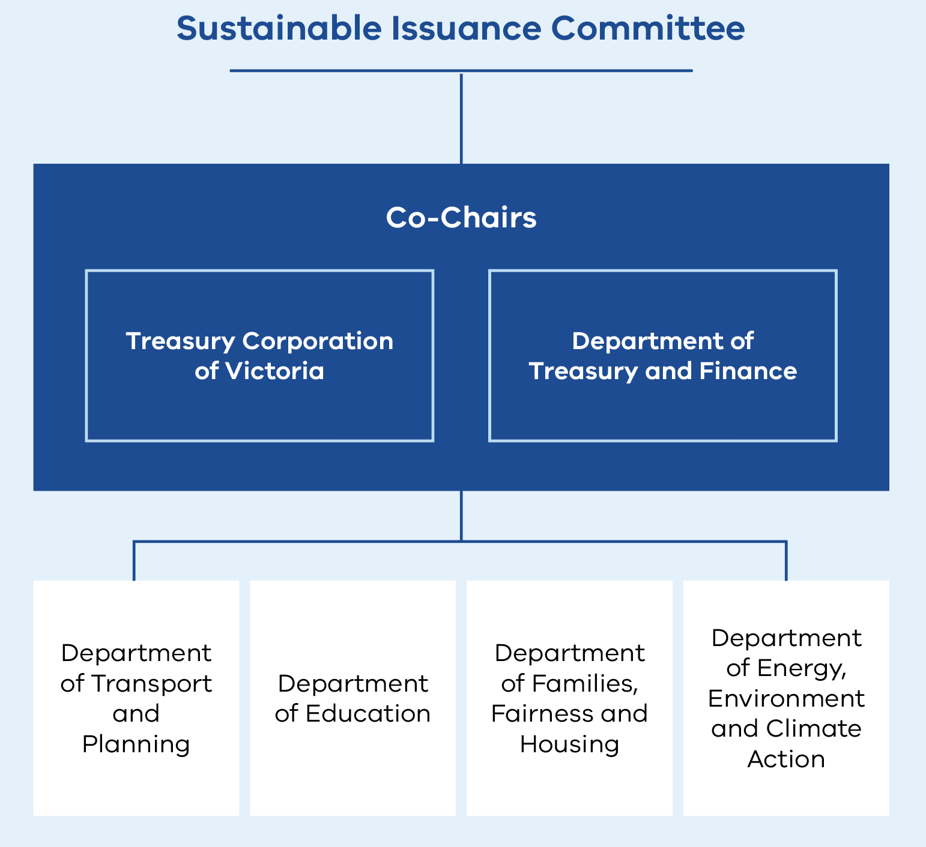
The Committee’s role encompasses
- To review and endorse any amendments to the Framework. The Committee will have oversight of the Framework with regard to maintenance and implementation.
- Governance process for Eligible Expenditure evaluation and selection. This includes:
- endorsement of Eligible Expenditures against the eligibility criteria
- adjudicate potential material ESG risks, by considering applicable mitigants and implications for the expenditure’s eligibility
- review and monitor the pool of Eligible Expenditures to ensure continuing project eligibility
- remove or reallocate the proceeds in the event the expenditure is no longer deemed eligible.
- Input, review and endorsement of annual allocation of bond proceeds and impact reporting.
- Consider the sustainable finance product development opportunities to support TCV’s ongoing issuance strategy and alignment to Government’s commitments, targets and policies.
Figure 4. Cross government, interdepartmental members of the Committee

 | Alignment with Victorian Government’s sustainability priorities | Adherence to environmental and planning requirements | Alignment with eligibility criteria | Availability of clear environmental and social benefits and data
Key considerations | Alignment of the Eligible Expenditures with the Victorian Government’s sustainability priorities and objectives, including consideration of ESG risk factors. | Adherence to environmental and planning requirements established under local, State and Federal legislations. | Alignment with ICMA categories and TCV eligibility criteria, as defined in Section 5.1 under ‘Eligible Expenditure guidelines’. | Availability of environmental and social benefits that can be measured using clear metrics for impact reporting.
Process for evaluation and selection | Identify and screen potential Eligible Expenditures through analysis of State budget documents and other relevant information. | Engage with relevant Victorian Government departments and Participating Authorities to capture supporting information and documentation. | Evaluate alignment with eligibility criteria for Eligible Expenditures.  Endorse for inclusion in the Eligible Expenditure pool.  Review existing Eligible Expenditures to ensure they continue to align with the eligibility criteria and continue to support the Victorian Government’s sustainability objectives. | Agree on annual reporting requirements (including quarterly reporting of expenditure, forecast expenditure, where available, and impact reporting metrics data and reporting requirements).
Accountability | TCV/DTF | TCV/DTF and other relevant Government stakeholders | Sustainable Issuance Committee | Sustainable Issuance Committee
Figure 5. Key considerations and processes

5.3. Management of proceeds

Allocated proceeds
Upon settlement, net proceeds from the Sustainability Instruments are deposited into TCV’s General Settlements bank account. Proceeds from the Sustainability Instruments and Eligible Expenditures will be tracked and reported via the use of internal information systems and financial records of the State of Victoria. Each Sustainability Instrument will have an amount equal to the net proceeds booked under an allocated position, established for each Sustainability Instrument within TCV’s internal systems. As outlined in Section 5.1, TCV commits to allocating proceeds within two financial years following issuance.
TCV will establish an internal register for all sustainable issuance and ensure net proceeds are notionally allocated to Eligible Expenditures within the eligibility window as shown in Figure 3. Net proceeds and Eligible Expenditures will be updated quarterly while allocation will be undertaken annually. Allocation of Sustainability Instrument(s) will be met when total net proceeds are fully allocated to Eligible Expenditures incurred. To the extent that any net proceeds of the Sustainability Instrument(s) remain unallocated, the net proceeds will be carried forward to be allocated in the two following financial years.

Unallocated proceeds
TCV will manage the unallocated net proceeds by investing in temporary investments such as cash, and cash equivalent instruments (such as short-term money market instruments), and/or labelled bonds. Unallocated net proceeds will not be invested in excluded expenditures.

Changes in standards and/or technical screening criteria
Where standards and/or the Australian Sustainable Finance Taxonomy change in future, TCV will grandfather the existing Sustainability Instrument and associated Eligible Expenditures based on the technical screening criteria in effect at the time of issuance. Future net proceeds from reverse enquiries, tenders and syndication of the existing and/or new Sustainability Instruments can be allocated to the associated remaining Eligible Expenditures whose technical screening criteria have been grandfathered.
Where Eligible Expenditures are added by TCV in the future, they are required to meet the technical screening criteria effective at the time the expenditures are added. TCV will aim to update the technical screening criteria following changes in standards and/or the Taxonomy.

5.4. Reporting
TCV understands the importance of transparency and will publish a TCV allocation and impact report on an annual basis, up until the maturity of all Sustainability Instruments outstanding. These disclosures, the Framework and external review reports (such as the Second Party Opinion) will be made publicly available on the TCV website.

Allocation reporting
TCV intends for annual allocation reporting to include the following information, in addition to any other information it deems material:
- face value and net proceeds from Sustainability Instruments outstanding, including the balance of unallocated net proceeds
- register of Eligible Expenditures, including description, amounts allocated to the Eligible Expenditure, amounts allocated to refinancing and alignment of each Eligible Expenditure to the relevant ICMA category and UN SDG
- report only relevant Victorian Government Eligible Expenditures to avoid double counting with any co-financed projects and programs
- confirmation of overall net proceeds allocated, and balance of any unallocated proceeds, at the conclusion of the reporting period.

Impact reporting
TCV will also report on relevant environmental or social impact metrics where relevant and feasible. Annual impact reporting will endeavour to be aligned with ICMA guidance on impact reporting or other industry standards as relevant and will aim to include the calculation methodologies used and underlying assumptions, where relevant.
Refer to the Appendix for indicative environmental and social impact and associated co-benefit metrics that TCV may use when reporting on the impact of Eligible Green and Social Expenditures.

5.5. External review

Second Party Opinion
TCV has obtained a Second Party Opinion (SPO) on the Framework from Moody’s Ratings, confirming its alignment to the ICMA Principles and adherence or reference, where relevant and applicable, to the Australian Sustainable Finance Taxonomy.

Verification
TCV’s allocation and impact reporting will be subject to external verification on an annual basis by an independent third party to confirm proceeds have been allocated in accordance with the Framework and ICMA Principles.

5.6. Continuous Improvement
TCV is committed to continuous improvement and welcomes feedback or questions on the Framework from investors and other stakeholders.
TCV may seek to update this Framework over time to ensure that it remains in line with market best practice and evolving investor preferences, and to reflect any significant changes in the Victorian policy landscape. Where material updates are made, TCV will procure a revised SPO.
For all enquiries or to provide feedback please contact tcv@tcv.vic.gov.au or the TCV Head of Sustainability at + 61 3 9650 4800 (TCV general phone number).

6. Appendix
Table 3. Green Expenditures impact metrics
ICMA Category | Indicative environmental impact metrics | Indicative social co-benefit impact metrics
Renewable energy | - GHG emissions avoided (tCO₂-e/yr)  - Installed generation capacity (MW)  - Number of applications for rebates or loans for owner-occupied and rental households approved  - Renewable energy capacity to be enabled by transmission systems (GW)  - Total energy storage capacity installed (MWh)  - Total percentage share of Victorian energy generation from renewable sources (%)  - New electricity transmission lines (km) | - Number of local jobs created/supported  - Apprenticeship/trainee opportunities created  - Local content commitment  - Number of households served with renewable energy
Energy efficiency | - GHG emissions avoided (tCO₂-e/yr)  - Number of upgrades completed  - Number of energy efficient appliances installed  - Number of applications for rebates to replace inefficient appliances approved | - Number of local jobs created/supported  - Apprenticeship/trainee opportunities created  - Local content commitment  - Number of households served with energy efficiency solutions
Clean transportation | - GHG emissions avoided (total tCO₂₋e/yr)  - GHG emissions (tCO₂-e per passenger/seat/capacity km)  - Number of new trains / trams / passenger cars  - Total MWh electricity consumption (MWh/yr)  - Passenger boardings  - Total kilometres travelled  - Number of vehicle chargers installed  - Total vehicle installed charging capacity (MW or kW) | - Number of jobs created/supported  - Apprenticeship/trainee opportunities created  - Procurement from local SMEs ($)  - Local content commitment  - Number of people with access to sustainable public transport systems
Green buildings | - Number of new buildings complying with green building standards  - NABERS energy rating or Green Star Building Rating  - Total greenhouse gas emissions, measured in tonnes of CO2 equivalent (tCO₂-e/yr)  - Emissions intensity, often measured in kilograms of CO2 equivalent per occupied bed day or per square metre (kgCO₂-e/OBD or kgCO₂-e/m²) | - Energy efficiency improvements for low-income households (%)  - Number of local jobs created/supported  - Apprenticeship/trainee opportunities created  - Number of new hospital beds  - Number of patients treated
Terrestrial and aquatic biodiversity | - Number of native plants or trees planted  - Area of catchments/wetlands covered by stewardship programs (ha)  - Area of land protected/under regenerative land processes (ha)  - Research projects completed/underway | - Number of local jobs created/supported  - Apprenticeship/trainee opportunities created  - Improvement of income of local populations (%)
Sustainable water and wastewater management | - Installed capacity (ML, ML/day, m³/yr or km for pipelines)  - Energy use (MWh/yr)  - Additional treatment capacity (ML/day)  - Reduction of nitrogen discharged (t/yr)  - Actual or potential gross water savings (ML/yr)  - Volume of clean drinking water supply (ML/yr or GL/yr)  - Waste to Energy capacity (MW or MWh/yr) | - Number of people served by pipeline or treatment plant  - Number of local jobs created/supported  - Apprenticeship/trainee opportunities created  - Number of people and/or enterprises benefitting from measures to mitigate consequences of floods and droughts
Climate change adaptation | - Number of flood or bushfire defences  - Area of flood or bushfire defences implemented (ha) | - Number of households with access to resilient energy/water supply  - Number of local jobs created/supported  - Apprenticeship/trainee opportunities created  - Number of people benefiting from measures to mitigate the impacts of climate-related disaster  - Adapted road, rail and infrastructure (km)
Table 4. Social Expenditures impact metrics
ICMA Category | Indicative social impact metrics | Indicative environmental co-benefit impact metrics
Affordable basic infrastructure | - Number of subsidised and/or free public transport passenger cards issued  - Number of subsidised and/or free public transport trips taken | - GHG emissions per passenger (tCO₂-e per passenger/yr)  - GHG emissions per kilometre travelled (tCO₂-e per vehicle-km travelled/yr)
Access to essential services | - Proportion of total government schools or students resourced through program (%)  - Number of education facilities and/or initiatives upgraded, completed or under construction | - Capacity of renewable energy installed (MW)  - Number of facilities complying with green building standards
Affordable housing | - Number of dwellings completed or under construction  - Number of dwellings allocated to specific target populations, for example, those with mental health or other disabilities, indigenous persons and those fleeing family violence (% and/or number)  - Number of individuals / families benefitting from subsidised housing | - Number of homes complying with green building standards
Socioeconomic advancement and empowerment | - Number of persons benefiting from vocational training  - Number of people benefiting from program facilities  - Number/capacity of refuges available for victims of family violence  - Number of people benefiting from disaster relief  - Number of people impacted by target population (e.g. First People) | - Number of projects financed to mitigate impacts of climate‑related disasters

7. Disclaimer
The establishment or any announcement of the Framework is not a recommendation, solicitation or invitation to purchase, hold or sell any Sustainability Instruments or notes or any other instruments issued or to be issued by TCV. The Framework is not a substitute for financial and social due diligence and the obligation to conduct such due diligence remains with the investor as it does for other investments.
TCV does not, and does not intend to, make any representation or give any assurance with respect to the Framework, Climate Bond Initiative’s Climate Bond Standards, ICMA Principles, the Australian Sustainable Finance Taxonomy or any of the reports provided by external assurance providers.
TCV is not responsible for any information, website, standard, report or guidelines published or provided by any external review provider, even where referred to in the Framework.
The United Nations Sustainable Development Goal icons are used throughout the Framework. The content of this publication has not been approved by the United Nations and does not reflect the views of the United Nations or its officials or Member States.
TCV also cannot and does not give any assurance in relation to the actual environmental or social impact of the Sustainability Instruments or any other notes or instruments, or of any projects generally.
This Framework and its disclaimer may be updated, amended or revised from time to time to reflect changes in laws, regulations, market standards or best practice. Any such updates will be published on the TCV website. Investors and stakeholders should refer to the most current version before making any decisions or relying on the information contained in this Framework.

Victoria’s Climate Science Report 2024
The latest round of sector pledges was published in 2025 and covers the period from 2026-30. See Victorian Government action on climate change.
Victoria’s Renewable Energy Investment Prospectus overview and sub-sector packs outline the opportunities arising from Victoria’s energy transition.
Blackrock Investment Institute (August 2024), ‘Capital at risk: nature through an investment lens’, Investment perspectives.
The Sustainability Fund supports businesses, local governments and communities through a range of waste management, recycling, resource efficiency and climate change programs.
See Stronger policy outcomes for Victoria.
Victoria’s energy workforce is projected to grow to 67,000 workers in 2040, an increase of greater than 60%. Most of this workforce will require vocational training or higher education qualifications to participate in the industry. The Government is developing the Victorian Energy Jobs Plan and the Women in Energy Strategy, which will support Victoria to develop an equitable and thriving renewable energy sector.
Refer to the Statewide Treaty Bill 2025.
Eligible Green Expenditures and Eligible Social Expenditures (collectively, ‘Eligible Expenditures’) include projects and assets across Victoria, which are funded through the Department of Treasury and Finance, Participating Authorities, and other state related entities, which aligns to Section 5.1 ‘Use of proceeds’.
For issuances via reverse enquiries and tenders, financing and refinancing composition will be available in the latest published Sustainable Bond annual impact and allocation report.
The parameters under this Framework apply to future reverse enquiries, tenders and syndications on the existing 2035 Sustainability Bond line, as well as new issuances. For the avoidance of doubt, reporting for the 2035 Sustainability Bond issued to date will report allocation of net proceeds based on Eligible Expenditures incurred going forward.
‘Year’ refers to Victorian budget financial year (i.e. period 1 July to 30 June).
Excluded expenditures apply only to the Sustainability Instruments issued under this Sustainable Bond Framework and not applicable to TCV’s broader funding programs.
For example, the ICMA ‘Sustainable Bonds for Nature: A Practitioner’s Guide’ (June 2025).
For example, the specific criteria for eligible Green Enabling Projects as captured in the ICMA Green Enabling Projects Guidance document (June 2024).
The Australian Sustainable Finance Taxonomy provides proxies for technical screening criteria that may be used to guide investment in green buildings (including new construction, acquisition and ownership, renovation and upgrades and replacement of major plant and equipment) in Australia.
Investment in energy efficiency will be considered as Eligible Expenditures where the upgrade or renovation project achieves energy efficiency improvements of at least 30% against a business-as-usual baseline, or where expenditure relates to specific upgrades through installation of energy efficient components.
As noted under Section 2.2, although pollution prevention and building a circular economy is a strategic priority for Victoria, the mechanism for funding the initiatives is primarily via the Sustainability Fund. However, wastewater treatment and associated waste to energy projects are included as Eligible Green Expenditures and may be funded via TCV.
See ICMA Harmonised Framework for Impact Reporting (June 2024).

